Adding a New Poem to the Current Issue

Three flavors of poem are currently supported, and two are under development.

**Currently**:

* Lineated poems with any amount of in-line whitespace;
* Prose poetry

**In Development**:

* Image-based poems
* PDF-based poems
* Poems with very long lines requiring a hanging indent

## Lineated poems

Lineated poems should be formatted in the following manner:

---  
title: "POEM TITLE HERE"  
contributor: "AUTHOR NAME HERE"  
---  
  
``` <!-- Three backticks -->  
 <!-- One linebreak -->  
So much depends  
upon  
  
a red wheel  
barrow  
  
glazed with rain  
water  
  
beside the white  
chickens  
 <!-- One linebreak -->  
``` <!-- Three backticks -->

## Prose poetry

For prose poetry, no backticks are required. Indicate new paragraphs with a blank line:

---  
title: "POEM TITLE HERE"  
contributor: "AUTHOR NAME HERE"  
---  
  
This is a paragraph. Since it is poetry, anything goes, even  
though it looks like prose.  
  
This is a new paragraph -- the same "rules" apply here.

# Posting Poems

New poems must be saved in the directory Trilobite/issues/_current/. They need to be saved as markdown files (with a .md file extension), rather than ordinary textfiles (.txt extension):

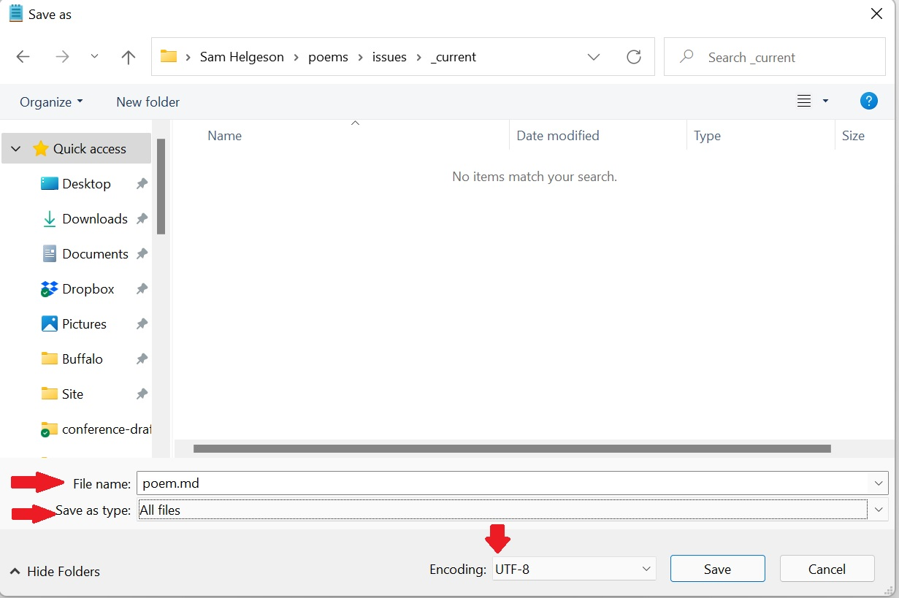

How to Save Poem Files

After saving all desired files, open **Github Desktop**. This program allows synchronizes your local files to the site. Github has an irritating number of checks and balances to prevent synchronization problems, but the steps are simple:

1. Hit “Fetch Origin.” If changes have been made to the site (by me, for example), the same button will change from “Fetch” to “Pull.” If this happens, hit “Pull” also.
2. Summarize your changes (*e.g.*, “Issue #1”). Optionally, write a lengthier description of any changes.
3. “Commit to main.”

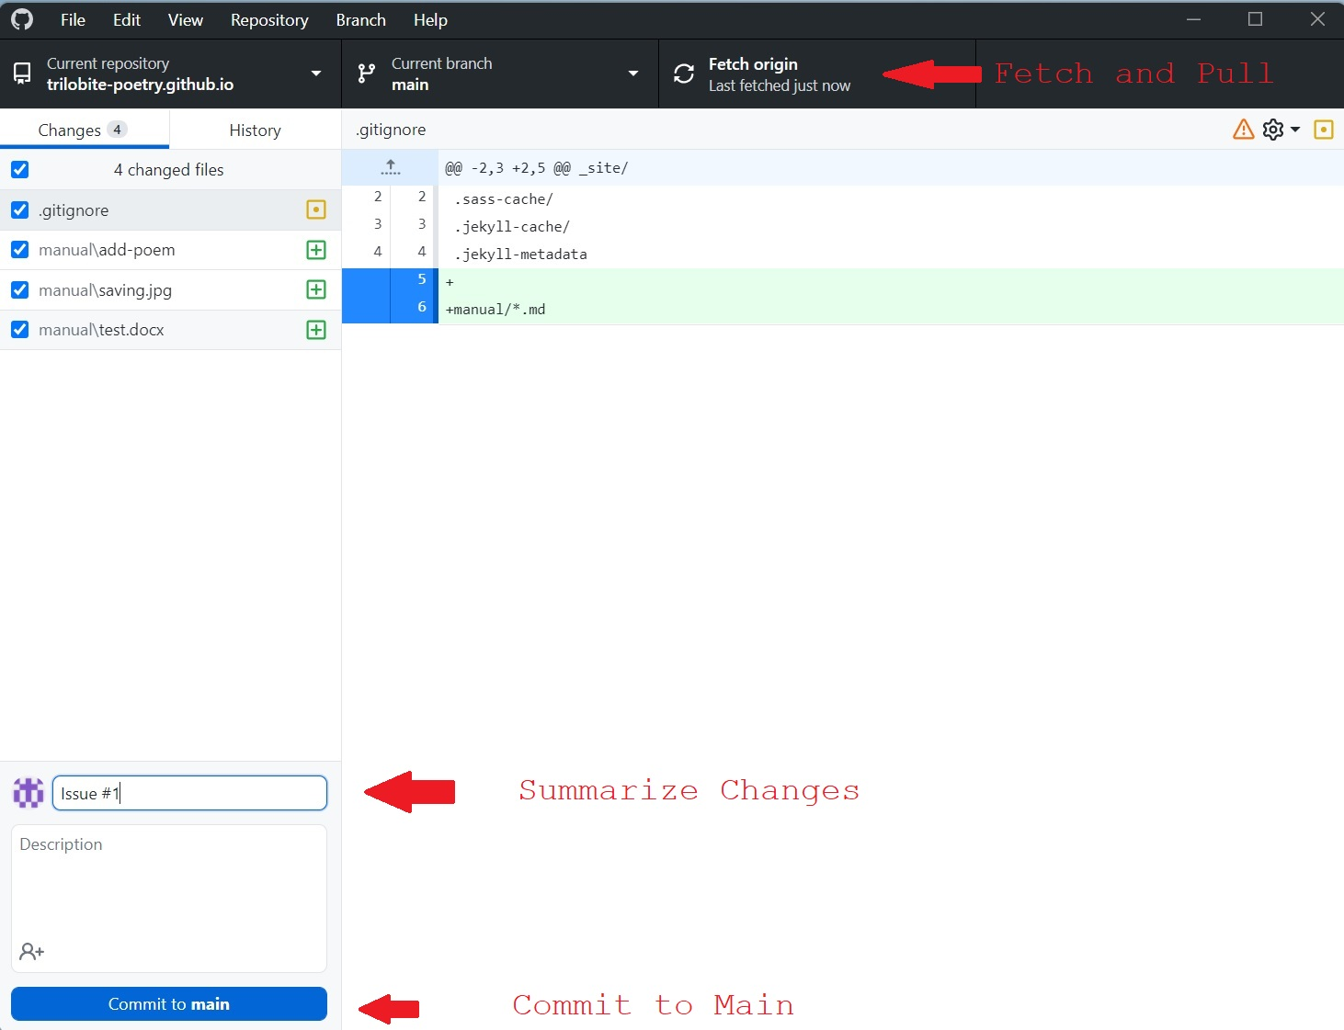

Github Desktop

1. Hit “Push Origin” to finalize your changes.

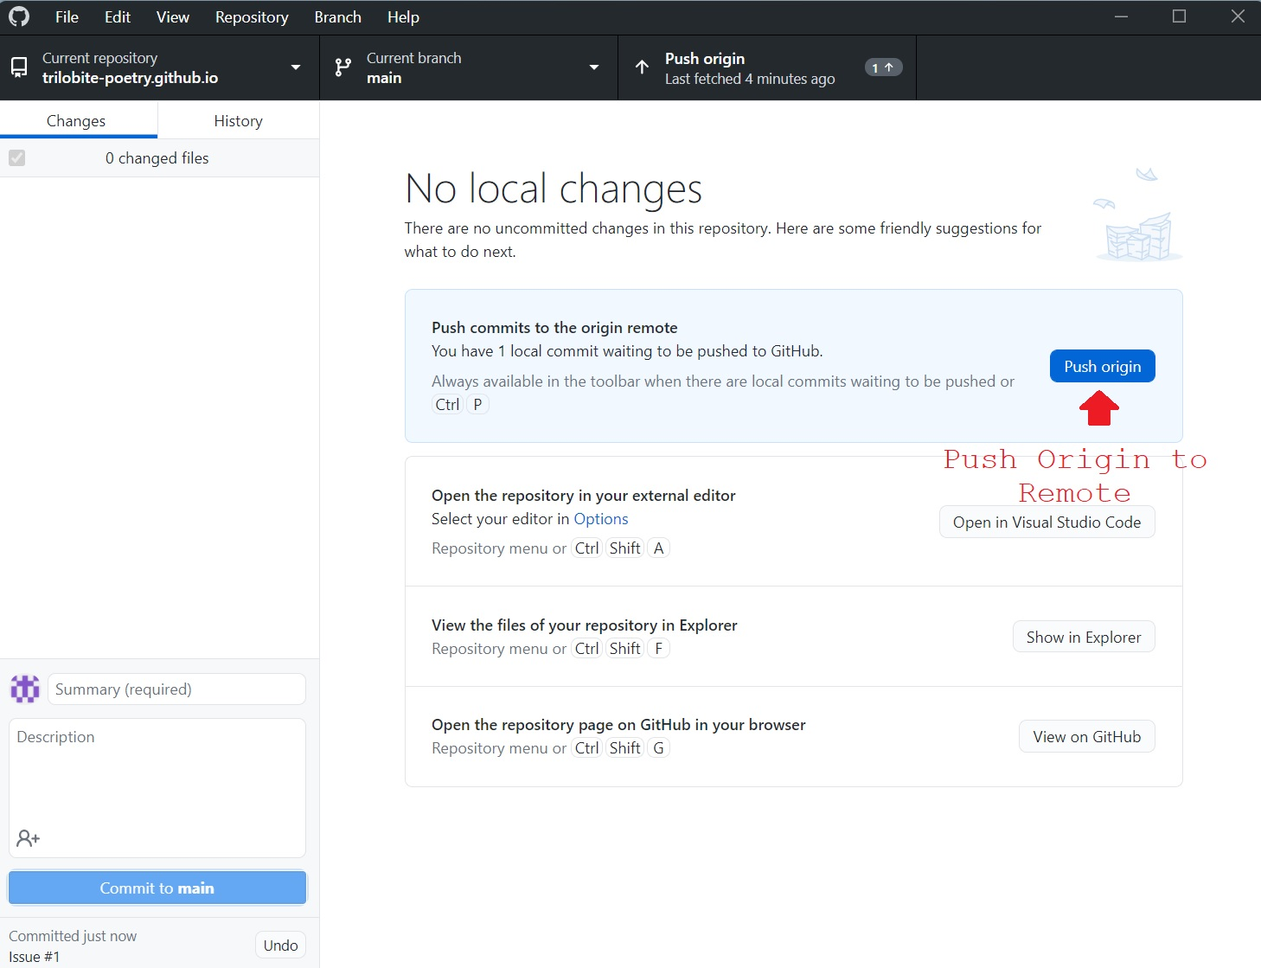

Github Desktop

1. Allow time for Jekyll to build the site before confirming that results are as desired (~4-5min).